WORLD BOOK DAY 2022 – THURSDAY 3RD MARCH
17TH February 2022

Dear Parents and Guardians,

After half term, we will be once again celebrating World Book Day, taking place on Thursday 3rd March. Following its success several years ago, we are looking forward to enjoying the day by hosting a vocabulary parade. We would ask that all children come into school dressed up as a word – the more unique, the better! There are many examples online if you google ‘vocabulary parade’. Please see several examples below:
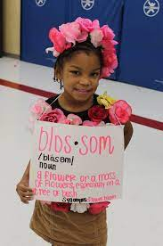
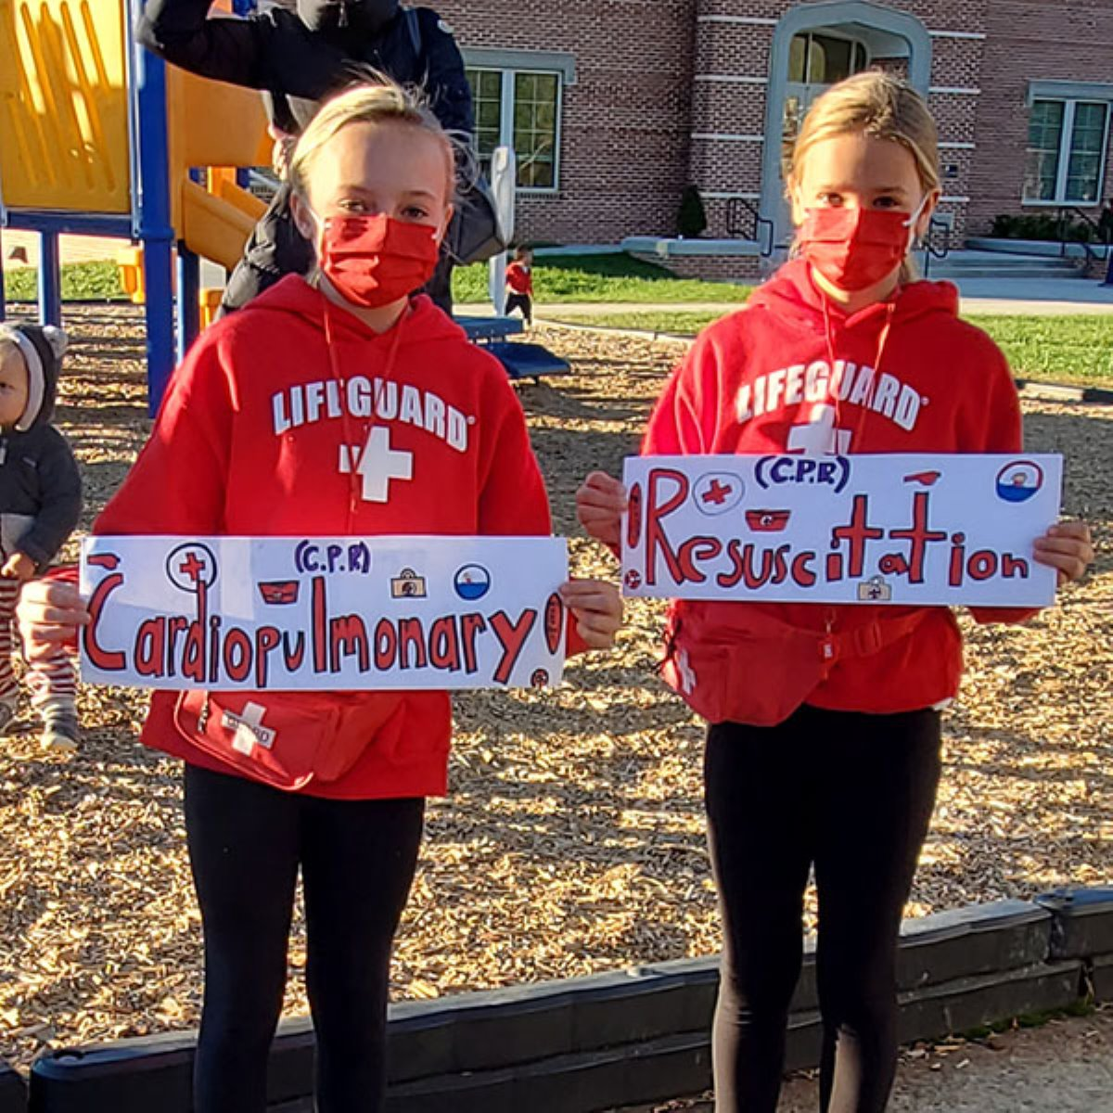
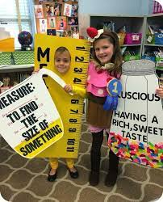

Additionally, we are also holding a World Book Day competition – the ‘book face challenge’ - with several prizes up for offer for the best entries. There are many examples of how to do this online and please see some ideas on the next page. Feel free to complete this individually or in sibling groups, but we would ask for photos of entries to be emailed to the school office by Friday 4th March, to then choose our winner.
Many thanks,
Miss Neal

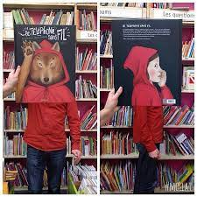
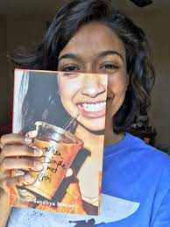
Book Face Challenge

