Park Primary School
Pupil Premium Overview of Results
2015-2016

Key Stage Two - Progress
Reading – Overall Progress Score
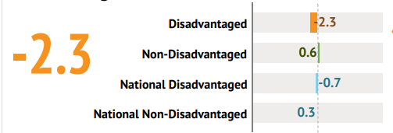
The Reading Overall Progress Score amongst disadvantaged pupils is 1.6 points less than the national disadvantaged pupils average.

Writing – Overall Progress Score
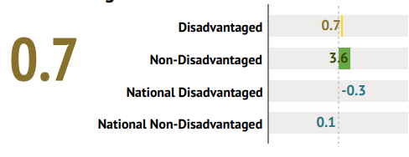
The Writing Overall Progress Score amongst disadvantaged pupils is 1.0 points greater than the national disadvantaged pupils average.

Maths – Overall Progress Score
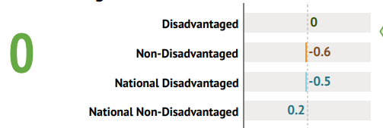
The Maths Overall Progress Score amongst disadvantaged students is 0.6 points greater than the non-disadvantaged pupils average, and 0.5 points greater than the national disadvantaged pupils average.

Key Stage Two - Attainment
Achieving the Expected Standard in all core subjects
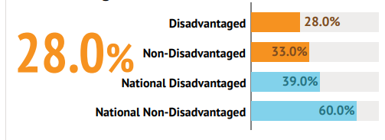
The proportion of disadvantaged students at Park achieving the expected standard in Reading, Writing (TA) and Maths is 5.0% less than the non-disadvantaged students average.

Achieving the higher standard in all core subjects
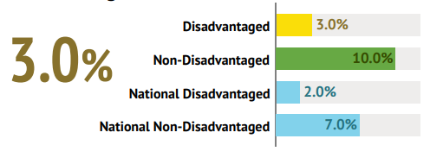
The proportion of disadvantaged students at Park achieving higher standard in Reading, Writing and Maths is 7.0% less than the non disadvantaged pupils average, but 1.0% greater than the national disadvantaged pupils average.

Reading – Achieving the expected standard
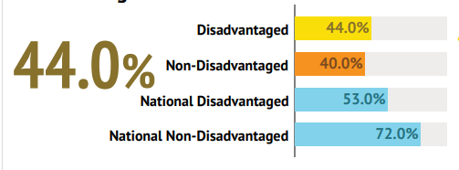
The proportion of disadvantaged students at Park achieving the expected standard in Reading is 4.0% greater than the non disadvantaged pupils average, but 9.0% less than the national disadvantaged pupils average.

Reading – Average scaled score
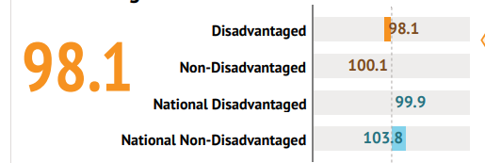
The KS2 AvSS for Reading amongst disadvantaged pupils is 2.0 points less than the non-disadvantaged pupils average, and 1.8 points less than the national disadvantaged students average.

Writing – Achieving the expected standard
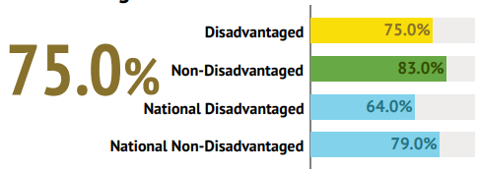
The proportion of disadvantaged students at Park working at the expected standard in Writing is 11.0% greater than the national disadvantaged pupils average.

Maths – Achieving the expected standard
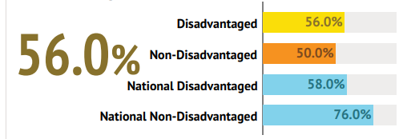
The proportion of disadvantaged pupils at Park achieving the expected standard in Maths is 6.0% greater than the non disadvantaged pupils average, but 2.0% less than the national disadvantaged pupils average.

Maths – Average scaled score
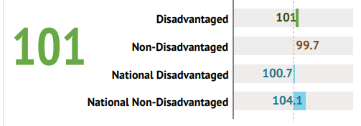
The KS2 AvSS for Maths amongst disadvantaged pupils is 1.3 points greater than the non-disadvantaged students average, and 0.3 points greater than the national disadvantaged students average.

EGPs – Achieving the expected standard
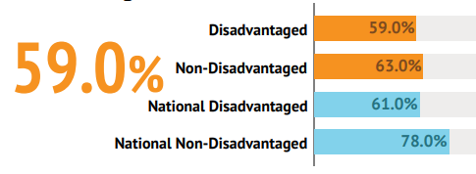
The proportion of disadvantaged students at Park achieving the expected standard in English Grammar, Punctuation and Spelling is 2.0% less than the national disadvantaged pupils average.

EGPs – Average scaled score
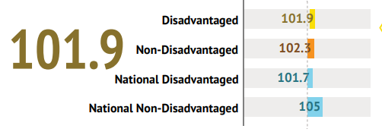
The KS2 AvSS for English Grammar, Punctuation and Spelling amongst disadvantaged students is 0.2 points greater than the national disadvantaged pupils average.

Key Stage 1
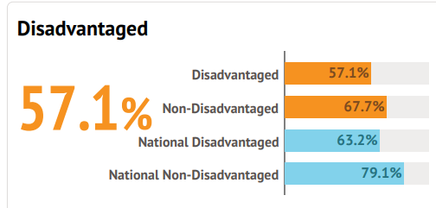
Reading - Achieving the expected standard
The percentage of disadvantaged pupils at Park Primary School achieving the expected standard in reading is 6.1% less than the national Disadvantaged average. The school gap has narrowed by 0.8% since last year.

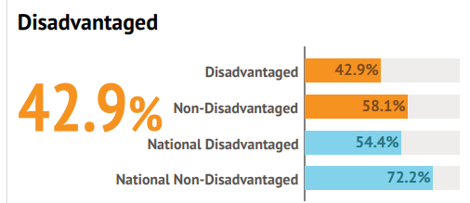
Writing – Achieving the expected standard
The percentage of disadvantaged pupils at Park Primary School achieving the expected standard in writing is 15.2% lower than the non disadvantaged pupils average, and 11.5% lower than the national Disadvantaged average

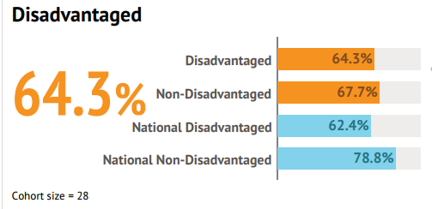
Maths – Achieving the expected standard
The percentage of disadvantaged students achieving the expected standard in maths is 3.4% lower than the non disadvantaged students average, and 1.9% higher than the national Disadvantaged average.

Phonics
Data Coming Soon

